E.C.C.O. report for NKF-N Annual Meeting, 2019
by Ekaterina Pasnak, E.C.C.O. representative

E.C.C.O the European Confederation of Conservator-Restorers´ Organizations (E.C.C.O.www.ecco-eu.org) represents the professional interests of conservator-restorers across Europe. Its mission is “to promote the profession of the Conservator-Restorer and to strengthen the role and responsibilities of the Conservator-Restorer in relation to others in safeguarding cultural heritage.”

Last year 2018 which was the year of European Cultural Heritage E.C.C.O. general meeting was held in the capital of Malta on April 29th and 30th, the historical city of Valetta which also happened to be the cultural capital of Europe for 2018. Valetta’s city and castle were built by the Military Maltese order. After defeating the Ottomans, the knights decided to build the castle and stay on the island to protect the inhabitants from pirates and Ottoman invasion. E.C.C.O can be seen in a similar vein as an organization that realizes the need to protect the good cause of preservation of heritage and conservation profession and uses available political means to achieve it.

E.C.C.O is becoming increasingly more active in European cultural politics, trying to make the voice of the conservator heard and create policies around heritage that reflect conservation point of view.

I. E.C.C.O. work within the Council of Europe
The Council of Europe is responsible for human rights and culture within Europe. Although Norway is not part of European Union, it is part of European Council.

1. CDCPP GROUP
Within European Council there is a group called CDCPP (Steering Committee for Culture, Heritage and Landscape).
A. STRATEGY 21 within CDCPP
CDCPP committee has been occupied with strategy 21 (European Cultural Heritage Strategy for the 21st century) and implementation of Faro convention.
E.C.C.O. was invited to be observers at CDCPP by invitation of Ana Schoebel, textile conservator and manager of Strategy 21. The present Strategy 21 https://search.coe.int/cm/Pages/result_details.aspx?ObjectID=09000016806f6a03
that had been ratified in 2016, unfortunately does no reflect our understanding of the conservation profession. The committee works to change definitions of conservation and explain better our involvement with cultural heritage.

a. Facts sheet for Strategy 21
As part of this work for Strategy 21, E.C.C.O. was invited to write Facts sheet, explaining in less than 1000 words what is conservation/restoration of cultural heritage https://rm.coe.int/strategy-21-conservation-restoration-of-cultural-heritage-in-less-than/16807bfbba
As well as preventive conservation of cultural heritage https://rm.coe.int/strategy-21-preventive-conservation-of-cultural-heritage-in-less-than-/16807bfbb9

These texts are written for general public and the wording can be used in our daily work when trying to explain to our non-conservation colleagues and leadership what conservation is about and how they should understand our work.

B. FARO CONVENTION
CDCPP is also occupied with implementation of Faro convention within European countries. http://www.ecco-eu.org/fileadmin/user_upload/CETS_199.docxFARO_CONVENTION.pdf
It is stressing the Value of Cultural Heritage for Society, recognition of the inherent right of the society to be involved in cultural heritage, that conservation of cultural heritage serves as a goal for human development and quality of life. It is dated 27.10.2005. Norway has signed it in 2008 and has ratified it in 2011. This convention can be used to emphasise the need of conservation for the improvement of quality of life of a community.

Questions that are put to discussion and that come out of the Faro convention: On what level should the public be involved? Should immigrants, unemployed people be given the right to work on culturally significant sites? To what extent?
Example from Slovakia: Government gave money to the unemployed to restore historical castles.
Comment: “We, conservators, have to see the society and its needs, otherwise we, expert conservators, will be going up the hill all the time”.

2. VOICES OF CULTURE
http://www.voicesofculture.eu
It is the platform where EU meets civil society or in other words where a structured dialogue is created between the European Commission and the cultural sector. Various stakeholders, i.e. various cultural organisations meet and discuss issues on culture in Europe. Among these stakeholders or European organisations are E.C.C.O. EnCoRe, ICCROM, ICOMOS, Europa Nostra and many others.

A. E.C.C.O participates in a group called ‘Skills, Training and Knowledge Transfer: Traditional and Emerging Heritage”
They are working on integrated approach, of defining roles various professions play within the cultural sector.
This mapping of roles consists of four parts:
Experts (conservators, art historians),
Mediation (Managers, lawyers),
Policy makers (local government)
and finally Public

This group is mapping missions and describing expertise of various professions.

At present cultural sector is not well defined and many professions, including conservation, do not have what is called NACE code, a professional code that defines placement of the profession within the tax system, salary, economy, etc. If such code is lacking, then in the eyes of the society such a professional group does not exist, does not contribute to the well being of the society and thus is dismissed as having importance.

It is hoped that the result of this work within VOICES OF CULTURE would be better defined and better recognised conservation profession.

D. OMC GROUP (Open method of coordination) – part of the European Commission, represent various governments and gives advice to the ministries of culture. ”It is a flexible but structured way EU Member States use to cooperate at European level in the field of culture”.

One of E.C.C.O. committee member actually represents Spain in OMC group. They make an effort to explain to the policy makers on the government level that experts in European Cultural Heritage should be acknowledged.

The ultimate goal in policy making right now is “integrated approach towards cultural heritage”.

The latest document “Mapping of Cultural Heritage”… from 2017 is available here http://www.ecco-eu.org/fileadmin/user_upload/Mapping_Cultural_Heritage.pdf

E. Out of this work of the Voices of Culture came the ICOMOS conference on Ethics that was held in Florence in March 2018.

F. Conservators need to know the legal framework they are working in, for example what we should do if one happens to receive a stolen artwork for conservation. Jeremy Hutchings wrote a ICOM-Newsletter for the working group “Legal Issues in conservation” www.icom-cc.org/legal-issues-in-conservation

(NB: to have access to this newsletter one need to be member of ICOM-CC)

3.YEAR OF CULTURAL HERITAGE 2018
Many activities were held in 2018 recognizing the importance of cultural heritage for European society and acknowledging the role of a conservator as an upholder of that heritage. Most of the conservation related events were held on the 14th of October, which was chosen as a conservation day.
This European Week of Conservation-Restoration aimed:
- to bring Europe’s cultural heritage, history and shared values closer to people;
- to engage the younger generation in the care of cultural heritage;
- to highlight special themes in conservation-restoration which are important in the preservation of Cultural Heritage as authenticity, awareness, access, sustainability

As part of this work, a list of conservation organisations was published on Wikipedia:
https://en.wikipedia.org/wiki/List_of_cultural_conservation-restoration_organizations
None of the Scandinavian NKF organisations are listed there. Perhaps this should be addressed

III ENCoRE.
(European Network for Conservation-Restoration Education)
It is through the efforts of this organization that most institutions require that a conservator should have Master’s level from an institution recognized by ENCoRE. In 2006 – it has been agreed that to practice independently conservator should have level 7, i.e. Master level.

At the General Assembly in Turin it was decided that UiO will no longer be a full member and is downgraded to associate member, mainly because there is not enough practical component in the Bachelor degree according to ENCoRE standard. However it can be changed again if situation is improved.

IV General Assembly 30.04.2018
1. Voting on the changing of the E.C.C.O. fees.

It was voted that they system of charging fees will be based not on the flat fee for everybody but on GDP of the country. There were two models proposed:
1. One was purely based on GDP
2. The other was 50-50, half based on GDP and half on basic flat fee.

In the first model the rich countries have to pay much more than previously and the poorer much less. To reduce the shock for countries with high GDP, the second model was proposed and it received most votes.

In 2018 the fees were the same as in 2017. The new system comes into effect in 2019. This system is flexible as GDP changes from year to year. In 2019 Norway will pay 100 euros flat fee plus an extra charge of 9,13 euros for each ordinary member. If ordinary membership will be over 200, then flat fee would be 150 euros.
2. CEPLIS – organization dedicated to regulation of liberal professions
It is hard to make conservation a regulated profession like doctors or lawyers. Politicians are against regulation of liberal professions. They would rather allow freer exchange and mobility of people, relying mostly on market to define who is good and who is not.

At present Slovakia has conservation as regulated profession. They need to register in the chamber of commerce and get license. Also in Greece conservation is a regulated profession, they have strong bond with the ministry of culture. It happens now in Malta as well.
Portugal, Italy and Spain wrote a joined manifesto for the profession, appealing to governments to change or strengthen the legislation to recognize and regulate the profession og conservaton .

3.CEN – Organisation that is publishing standards on European level.
Those that are related to conservation are organized under WG 11
Sweden has made those standards free for use for three years.
A forum on collection management - Årets samlingsforum was held in November 2018 in Visby with a focus on standards. Sweden hopes that by adopting these standards as a regular practice, it would be easier to maintain quality of work within the Heritage sector.

4. Communication
E.C.C.O. asks for a representative from each organization in order to coordinate communication between the National organization and E.C.C.O. via websites, Facebook and Twitter, i.e. media contact. From now on national reports will be posted on our website (in English) and the link should be given to E.C.C.O.

5. National Reports
France has a continued struggle for choosing a title for a conservator.
The government has finally accepted that conservators should be recognized and have their own title. Since conservateur (conservator) is reserved for curators, and restaurateur is associated with restaurant business and crafts, they suggested “ingenieur de conservacion et restauracion” (engineer of conservation)
E.C.C.O. committee members were very much against the term “engineer” as engineers do not advocate cultural values. Also in Germany engineers did not want to accept conservators in their midst as they do not deal with math and physics.

This should be taken for further consideration in Norway. Conservators are not recognized and are not regulated. In the salary scale they are often placed within “Avdeling ingenør og Overingenør”. Perhaps it should be argued that it does not reflect our profession.
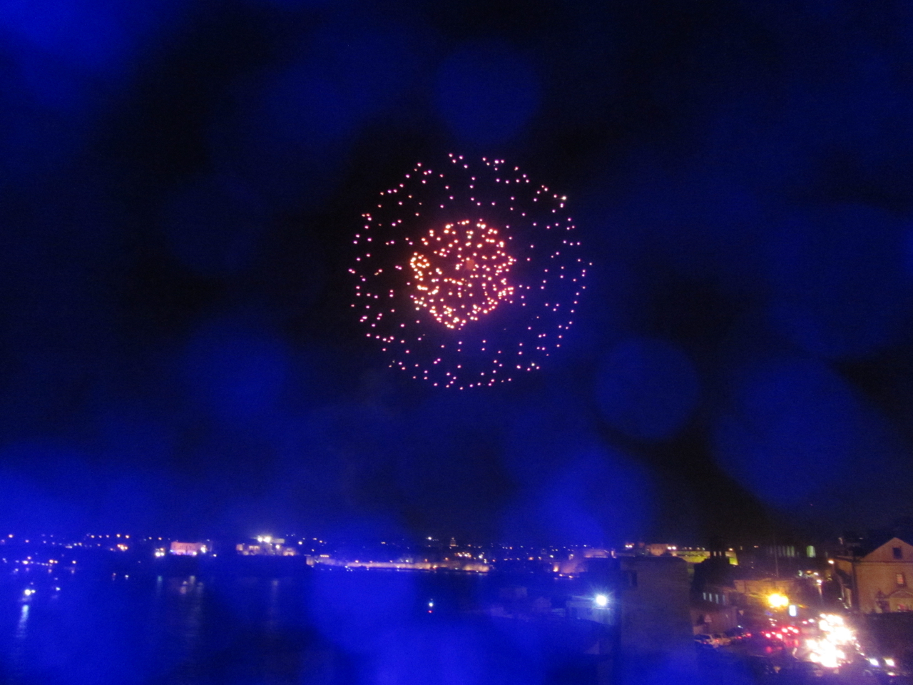

Fireworks over harbor in Valletta, April 30 in celebration of Malta joining EU on the 1st of May

In 2019 General Assembly will be held in Zagreb on April 1st. Latest E.C.C.O news will be brought to the NKF-N Annual Meeting.

